BLUE FLAME ALLIANCE (BFA)  began in 1999 as the Gas Foodservice Equipment Network. Over the past 20 years, we have grown into an alliance of utilities, foodservice manufacturers, cooking professionals, national accounts, and trade allies. We are an educated alliance compiled of natural gas leaders whose mission is to educate our peers in the industry about natural gas equipment, benefits, and new technologies. Our community of natural gas experts acts as a resource and guide to all of our members, providing them with the tools they need to strengthen their business.        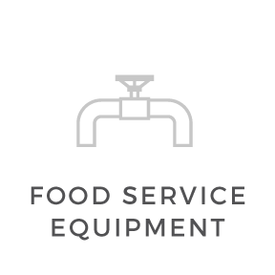    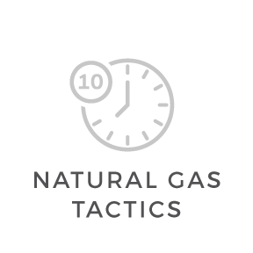  Solutions for commercial customers  The goal of Blue Flame Alliance is to help  commercial customers improve productivity, efficiency, and profitability. Clean-burning natural gas products offer commercial customers comfort, ambiance, and convenience. Joining BFA opens networking opportunities that you may be missing.  Learn more about joining Blue Flame Alliance at: BlueFlameAlliance.com/About-Us  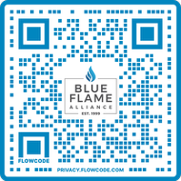  LEARN HOW NATURAL GAS IS THE EFFICIENT CHOICE  BLUEFLAME  ALLIANCE.COM | Our membership  Blue Flame Alliance offers utilities, trade allies and manufacturers extensive resources and up-to-date industry information from presentations to membership events and equipment demonstrations. Being a member of BFA gives you valuable knowledge through meaningful and consistent dialogue with national and regional commercial industry accounts.  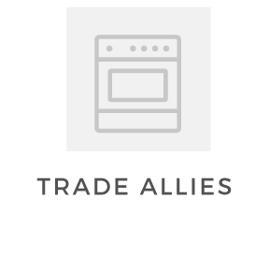  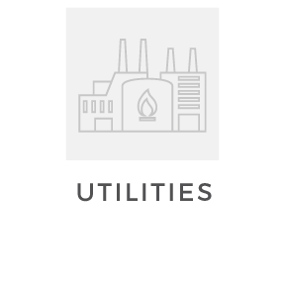  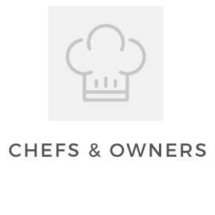    NETWORKING FOR  OFFERING RESOURCES SUCH AS  Cooking with gas  It’s no surprise that almost 88% of chefs prefer natural gas in their kitchen. Cooking with natural gas allows for:  - Controlled temperatures  - Even and thorough cooking  - Efficiency  - Instant heat  - Environmentally-friendly cooking
