

12/18/25 BFA Meeting Minutes
Attendees:
Danielle Branch | American Range | Richard Young | Frontier Energy
Nicole O'Rourke | American Range | David Zabrowski | Frontier Energy
Trish Riber | Black Hills Energy | Frank Johnson | GTI Energy
Ann Lovcik | CenterPoint Energy | Marti Sawyer | National Fuel Gas Distribution
Charles Kondek | DTE Energy | Cortney Dennis | ONE Gas
Celina Stratton | Energy Solutions | Lori Taylor | ONE Gas
Eric Burgis | Energy Solutions Center | William Morris | Piedmont Natural Gas
Ariana Catanjal-Cueva | Frontier Energy

- Meeting started at 2 PM Eastern
- Eric announced the addition of 5 new foodservice videos that have been added to the BFA site.
  - FS equipment replacement, ventilation and hot water efficiency videos can be found on: https://blueflamealliance.com/food-service-resources/equipment/
  - Cooking energy efficiency video is located on: https://blueflamealliance.com/food-service-resources/energy-star/
  - Benefits of Gas Cooking can be found at: https://blueflamealliance.com/food-service-resources/gas-chefs/
  - All 5 videos can also be downloaded in the BFA members only area at: https://www.energysolutionscenter.org/blue-flame-alliance-marketing-materials/
- Eric introduced Nicole O’Rourke & Danielle Brach with American Range who presented their line of gas cooking equipment to attendees. A copy of the presentation can be found in the BFA members only area on the BFA Presentations page at: https://www.energysolutionscenter.org/blue-flame-alliance-presentations/
- Lori Taylor presented the ONE Gas Education & Training Area (EAT) to attendees. This presentation can also be found in the BFA members only area at; https://www.energysolutionscenter.org/blue-flame-alliance-presentations/
- Ann loved the way Lori captured data on the 2nd to last slide of her presentation. Below is the content Ann referred to:
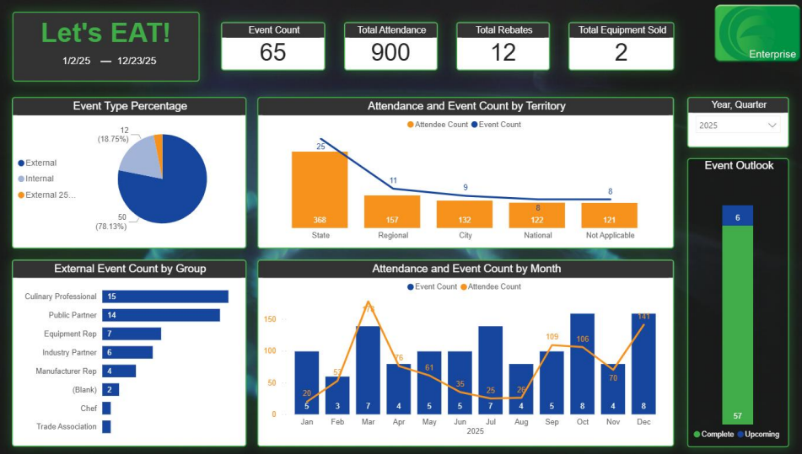
- Cortney noted that the ONE Gas leadership team is focused on lots of other items and they need to continually show leadership that the demo kitchen space is being utilized and adding value. Ultimately they would like to influence behavior. Various rep groups are now writing the ONE Gas event space into their goals. And as a regulated utility, ONE gas needs to show that the space is helping the LDC.
- Will asked if the ONE gas dashboard is manual or automatic.
  - Lori noted that it starts in a spreadsheet and tracking is done from there.
- Lori noted that they are more focused on then quality of an event and if a rep will be on-site, they dealers, chefs, etc. also at the event.
- Frank asked Lori if she is tracking types of equipment being tested or what category of equipment is being tested the most.
  - Lori said that flat breads and pizza demos are very popular.
  - David said a majority of demos he is seeing are combis and lots of pizza demos as well.
- Eric shared the 2026 speaker line up and asked for utility members to volunteer to share what they are doing in the foodservice market. These can be 5-10 minutes long and do not need to have slides. BFA leaders would like one Affiliate or manufacturer as well as one utility to present at each meeting The current 2026 line up is as follows:
  - Jan 15th: Celine Stratton-Energy Solutions & Will Morris-Piedmont NG
  - Feb 19th: Dean Stanley-Accutemp & Ann Lovcik-CenterPoint Energy
  - Apr 16th: Adam Dyer-Eloma USA & LDC TBD
  - May 12th: Woodstone Invited + NRA recap
  - Jul 16th: Frank Johnson-GTI & LDC TBD
  - October 19-21, 2026 Customer Care Workshop in Pleasanton, CA
  - Need speakers for 11/19 & 12/17 meetings
- Eric provided an update on the website, social media and articles from White Whale. This group will not be offering marketing services in 2026. Eric is working to relocate the BFA website to an ESC hosting arrangement.
- Eric noted that ESC has wrapped up its relationship with the current NA Relationships Manager. He is monitoring Greg’s emails through December when forwarding will stop. Eric noted that leaders did develop a new set of goals for a relationship manager should the consortium desire to replace Greg in the future.
- Ann asked what people thought about bringing FS news to calls.
- Ann suggested we do some round table discussions on industry changes and updates.
- David asked what the consortium wants out of a relationship manager.
  - Ann said the manager needs to bring attention to gas equipment.
  - Eric said that the relationship manager needs to build relationships with national foodservice operators and work to effect a change that includes gas solutions.
- Meeting adjourned at 3:00 PM

