

Minutes

3/17/26

Financial Report: $86K is available for future deliverables
Understandingchp.com has been updated recently
Manufacturer Updates: What's going on in the world of CHP? Trends, issues, growth?
- EV charging could be the next big development.
- Advertising to developers could be useful before they start new projects.
- Yanmar and TEDOM have merged.
RT: Power Production for Data Centers
Check out Unit 13 & 14 of Commercial II training on data centers.

RT: Utility Success stories or opportunities lost
- A challenge seen with data centers is that many just want short term power from gas utilities.
Future deliverables: What deliverables do you need to help promote CHP?
Members suggested a white paper on why CHP is a good solution for data centers

CHP Consortium Members

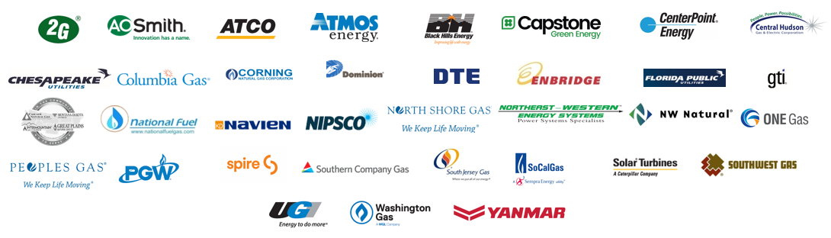

Attendees:

- Amir Ali — Jenbacher
- Chris Evans — OK Natural Gas
- Clint Kelly — Tedom, UST
- Curtis Nickerson — Atco Gas
- Eddie Caton — Yanmar
- Isaac Panzarella — DOE Onsite Energy [last word unclear]
- Jacob Kindberg — NFG
- James Curry — MEC (Mountaineer)
- James Leidel — DTE
- Jared Hughart— Chesapeake Utilities
- Jared Shelton — Chesapeake Util.
- Jessie Gilliland — Spive
- Joe Calhoun — UGI
- John Watson — W.W. Williams
- Kenneth Magee — Virginia Nat. Gas
- Kim Kelly — CenterPoint Energy
- Nathan Skantz — CenterPoint Energy
- Rich Kooy — GTI Energy
- Rhiannon Hazzard — UGI
- Tara Cunningham — Rinnai
- Donald Williams — W.W. Williams

