
Meeting Minutes – 1/13/26
Attendees:
Citizens Energy Group | David Peck | PGW | Michel Farag
Citizens Energy Group | Jeff Sinclair | Rinnai | Perry McGuire
Enbridge | Paoyun Liu | Rinnai | Kevin Morgan
ESC | Eric Burgis | South Jersey Gas | Bill Taylor
ESC | Sonia Vahedian | UGI Utilities | Joe Calhoun
MDU | Jon Whiting | UGI Utilities | Allison Dennison
NJNG | Katie Feery

- The meeting was called to order at approx. 2 PM ET
- Eric showed attendees a draft of the 1st of the 5 hydrogen white papers. He noted that the review team is due to have all comments in by 1/21.
- Eric asked members to share what their companies are working on to reduce carbon.
- Paoyun noted that Enbridge is big on GHPs. They did some residential pilots and looking to demo GHPs with commercial customers. Also working on DSM and energy savings. Enbridge has a new focus on resiliency.
- Katie echoed Paoyun that GHPs are hot right now. NJNG is also big on distributed carbon capture and has two CleanO2 CarbinX units installed in their own facilities as well as a carbon Reform unit. Her company is also working to interconnect landfill gas to their system. NJNG’s EE group rolled out a program for hybrid heating and has 130 hybrid systems in their territory so far.
- Bill is also in NJ with Elizabethtown Gas (South Jersey Gas). He noted that with hybrid retrofits they are not allowed to install a new gas furnace. If they have a gas furnace, they can install an EHP to replace the condensing unit, but not the furnace. There may be jurisdictional differences between his and Katie’s territories.
- Michel is doing hydrogen, GHPs, CHP, and EV powered by natural gas to support charging stations. Also, looking at site vs source electric.
- Michel asked if hybrid systems would impact design day conditions and affect the cost to serve customers.
  - Katie feels the impact is negligible now and the really cold peak periods will use gas as they have before.
- Paoyun asked Katie if they have M&V results for their Carbon Reform system.
  - Katie noted that NJNG is working on this.
  - Michel asked if there is any study on employee productivity as a result of Carbon Reform.
  - Eric noted that in theory productivity increases with this system which removes CO2 from the inside space air making it more O2 rich but proving out employees are more alert and more productive is a tough task.
- Joe has a half dozen landfill RNG projects interconnected to UGI and their unregulated subsidiary has a bunch more RNGs from landfill and wastewater treatment facilities. UGI is using CHP to rebalance carbon emissions. They are also blending RNG with natural gas and this makes a great ESG story.
- It was asked if anyone has done carbon capture with CHP.
  - Eric noted that Unison and 2G do this for sure. Other CHP manufacturers also do this.
- Joe asked if anyone is doing anything with gray hydrogen.
  - Eric commented that most of the available H2 today is gray H2 from SMR. There are a lot of utilities and manufacturers playing with admixtures or 100% H2 and most of that is gray H2 at present. It’s a bridge towards Blue, Turquoise, Green and Pink H2.
- Michel noted that Coca Cola was starting a pilot on three plants, one in his region. The pilot was to install CHP and make food grade CO2 out of the exhaust for use in products. All projects are on hold as the first ran into issues with the food grade quality of CO2 needed.
- Michel noted that he heard Pyrolysis isn’t allowed in the US and carbon black is a hazardous material.
  - Eric will ask GTI about this.
  - Paoyun noted that the NGIF is working with Enbridge on Pyrolysis. He stated that we started focusing on producing H2 from Pyrolysis, but now the focus has shifter to producing carbon black for use in tires, cement, batteries, etc.
  - Below is some info from GTI and AI on carbon black
- David noted that most of their opportunities are landfill RNG projects.
- Michel commented that they are finding it’s better for a customer to sell RNG than consume it onsite. He also noted that most of their RNG is going to fuel CNG vehicles.
- Perry informed attendees that Rinnai is challenging Los Angeles for banning standard tankless water heaters. Other states and regions are also doing this. Separately, all Rinnai units are certified for an admixture up to 25% H2.
  - Eric informed attendees that Rinnai is the only manufacturer producing tankless water heaters in the U.S. and ESC will tour the manufacturing facility on 3/16 as part of the 3/16-3/19/26 TMAF in Atlanta. More info and registration can be found at: https://www.energysolutionscenter.org/technology-market-assessment-forum-atlanta/
- Meeting adjourned at 2:50 PM

GTI Response to Carbon Black question
Completely agree, carbon black is produced at many sites in the US (as are many other hazardous materials). Monolith’s plant that was operating in NE is the easy example of natural gas pyrolysis-based CB production as well.

Carbon black is associated with regulated air pollutants (https://www.epa.gov/stationary-sources-air-pollution/carbon-black-production-area-sources-national-emission-standards), so its production is regulated (but not “illegal”). If that is what this person is referring to, the restrictions from EPA are important but not an outright “outlaw” of production. The applicable rule here is quite old (2008) and to my knowledge the proposed rule is stalled at the moment (unlikely to move soon). Keep in mind that EPA has weighed in on this recently (https://www.epa.gov/stationary-sources-air-pollution/final-national-emission-standards-hazardous-air-pollutants-carbon)

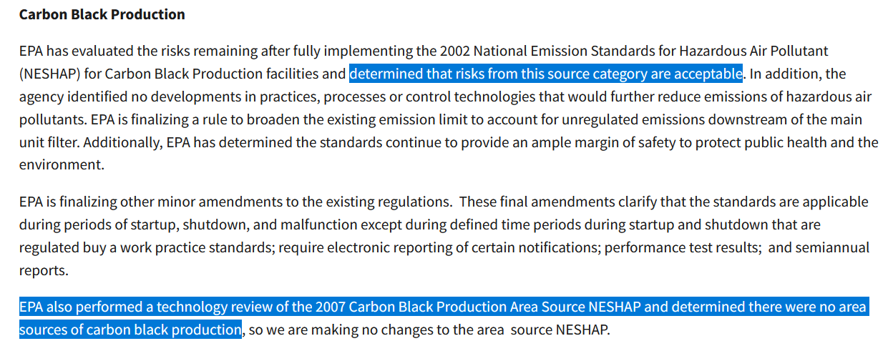
Important to note that, like most matters with EPA, scale matters. Per the rule (https://www.ecfr.gov/current/title-40/chapter-I/subchapter-C/part-63/subpart-MMMMMM / https://www.ecfr.gov/current/title-40/chapter-I/subchapter-C/part-63/subpart-YY/section-63.1103#p-63.1103(f)(2)) we’re talking about “major” sources here.

AI response to Carbon Black questions:

Is carbon black produced in the U. S.?
"Yes. Carbon black is produced in the United States, and the U.S. is one of the world’s significant producers.
Key points
- Primary use: Reinforcement filler for tires and other rubber products; also pigments, plastics, coatings, inks, and batteries.
- Feedstocks: Mainly heavy petroleum oils (and some natural gas–based processes).
- Geography: Production is concentrated near refineries and petrochemical hubs, especially along the Gulf Coast.
Major U.S. producers (examples)
- Cabot Corporation – multiple U.S. plants
- Birla Carbon – U.S. operations
- Orion Engineered Carbons – U.S. plants
- Phillips Carbon Black (PCBL) – U.S. presence
- Tokai Carbon – U.S. operations
Typical producing states
- Texas
- Louisiana
- Mississippi
- Arkansas
- Kentucky
- West Virginia"

Is carbon black regulated as a hazardous material?'
Carbon black is not classified as a hazardous material in the sense of being acutely toxic or flammable, but it is regulated as a health hazard due to inhalation risks, especially in occupational settings.
How it’s classified
- OSHA (U.S.):
  - Carbon black is regulated as a nuisance dust / particulate.
  - OSHA Permissible Exposure Limit (PEL): 3.5 mg/m³ (respirable fraction).
- NIOSH:
  - Recommends an exposure limit (REL) of 3.5 mg/m³ (TWA).
- IARC (International Agency for Research on Cancer):
  - Classified as Group 2B – Possibly carcinogenic to humans, based on sufficient evidence in animals and limited evidence in humans.
- DOT (transport):
  - Not classified as a hazardous material for transport (no UN hazardous materials number).
- EPA:
  - Not listed as a hazardous waste by default, but carbon black manufacturing facilities are regulated due to emissions (particulate matter, PAHs, SO₂, NOₓ).

Why it’s considered a health concern
- Primary risk: Inhalation of fine particles
- Potential effects:
  - Lung irritation
  - Reduced lung function with chronic exposure
  - Increased lung cancer risk at high, long-term occupational exposures
- Skin contact: Generally low toxicity; can cause mechanical irritation
- Ingestion: Low toxicity; not considered poisonous"

