
IMAC Consortium Minutes
03/19/26
Financial Update
- $2,700 remains in the budget.
Proposal
- A second round of funding is needed for the consortium to pursue any new future deliverables.
- A new Investment Prospectus was created and distributed to all members of the consortium.
- The Investment Prospectus has many new proposed training units based on feedback from members such as methane pyrolysis.
- $2k has been committed already.
Industrial & Commercial Industry Discussion
- Industrial success stories
- Challenges selling gas to industrial customers
- New technologies
- Carbon reduction strategies
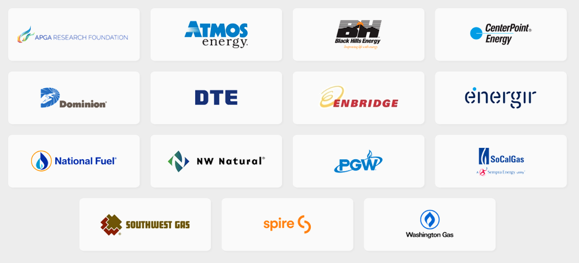
Consortium members:
Attendees
- Aqeel Zaidi- Enbridge Gas
- Camillo Velasquez- NW Natural
- Jacob Kindberg- National Fuel
- James Leidel- DTE
- Joe Imbrogno- Nicor Gas
- Raymond Edwards- NW Natural
- Steve Roberson- Spire

